Exercise 1: Control Structures
Step 1:
Create sample tables :
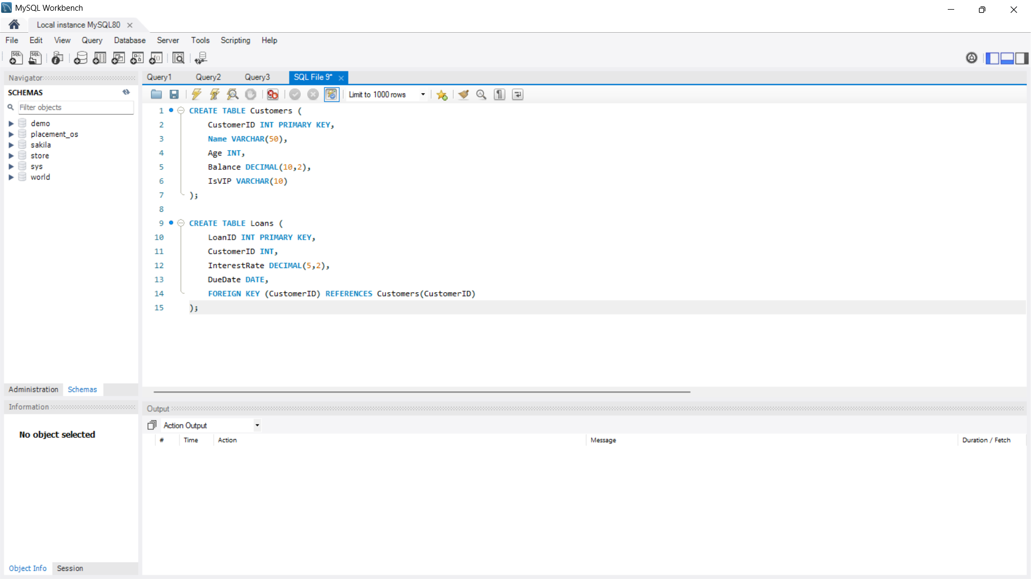
Step 2:

Insert sample data:
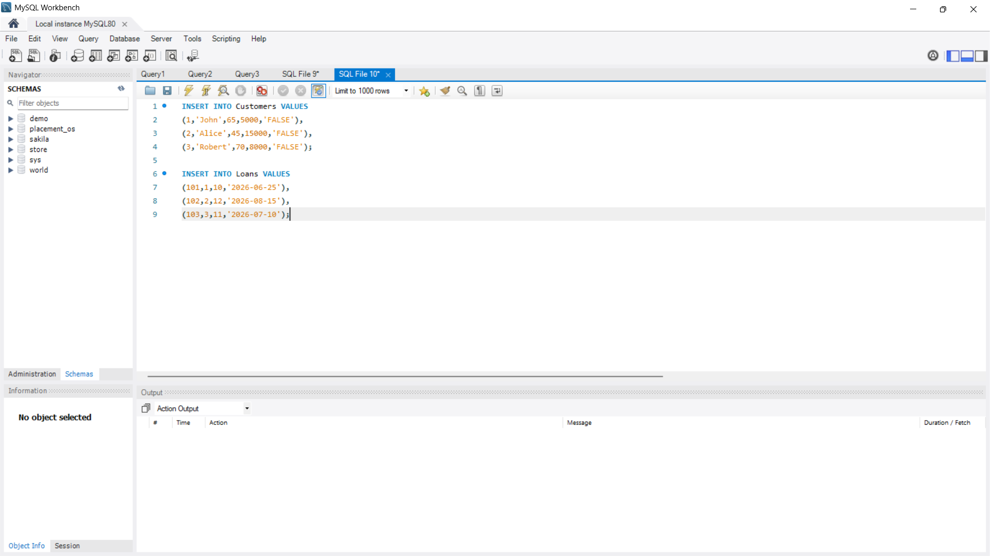

Scenario 1:
The bank wants to apply a discount to loan interest rates for customers above 60 years old.
Question:
Write a PL/SQL block that loops through all customers, checks their age, and if they are above 60, apply a 1% discount to their current loan interest rates.
Script / Query:
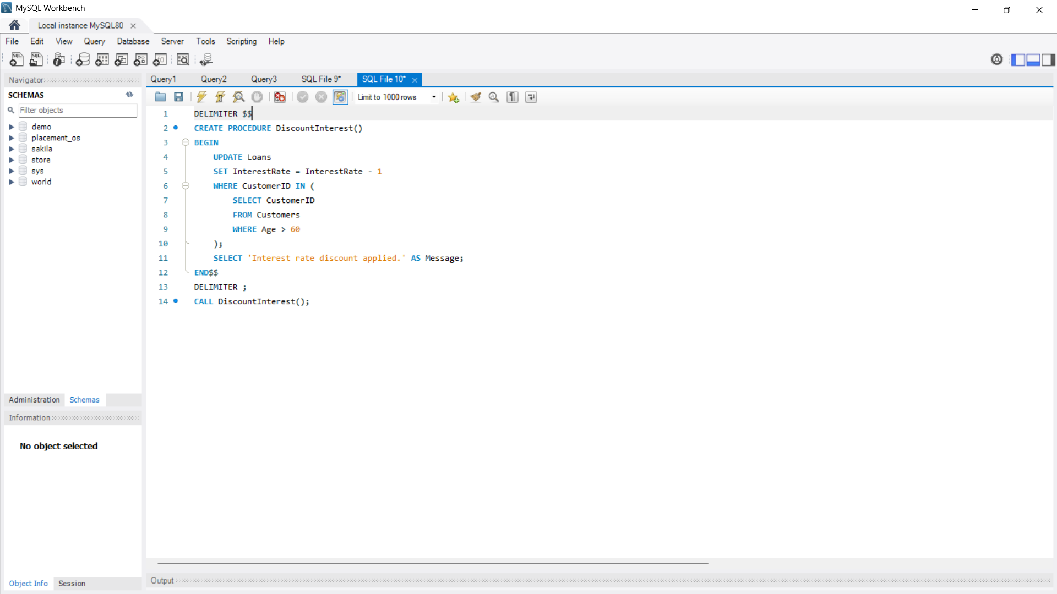
Output:
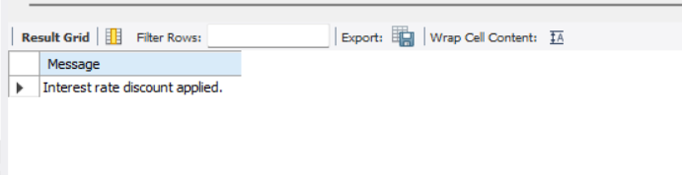

Explanation:
Applies a 1% discount to loan interest rates for customers whose age is above 60 years.

Scenario 2:
A customer can be promoted to VIP status based on their balance.
Question:
Write a PL/SQL block that iterates through all customers and sets a flag IsVIP to TRUE for those with a balance over $10,000.
Script / Query:
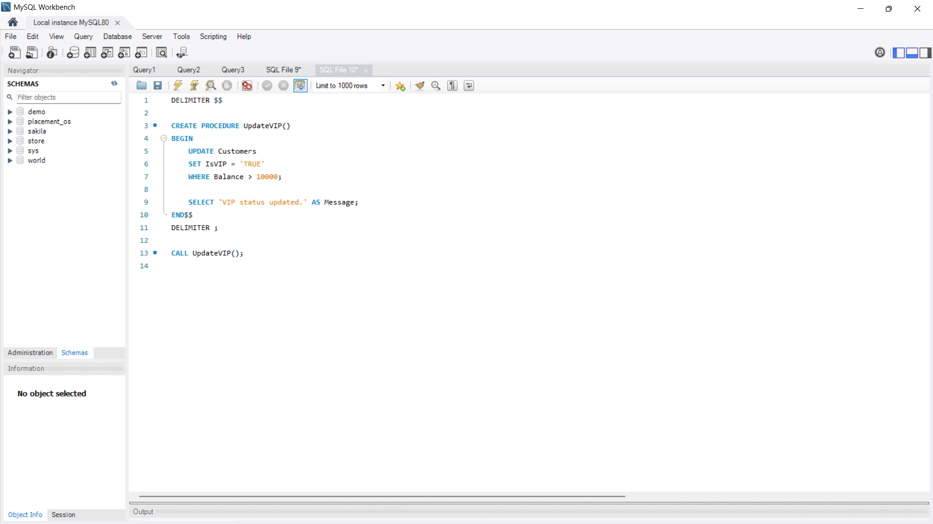
Output:
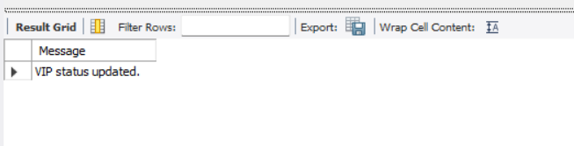
Explanation:
Updates all customers with a balance greater than 10000 as VIP.

Scenario 3:
The bank wants to send reminders to customers whose loans are due within the next 30 days.
Question:
Write a PL/SQL block that fetches all loans due in the next 30 days and prints a reminder message for each customer.
Script / Query:
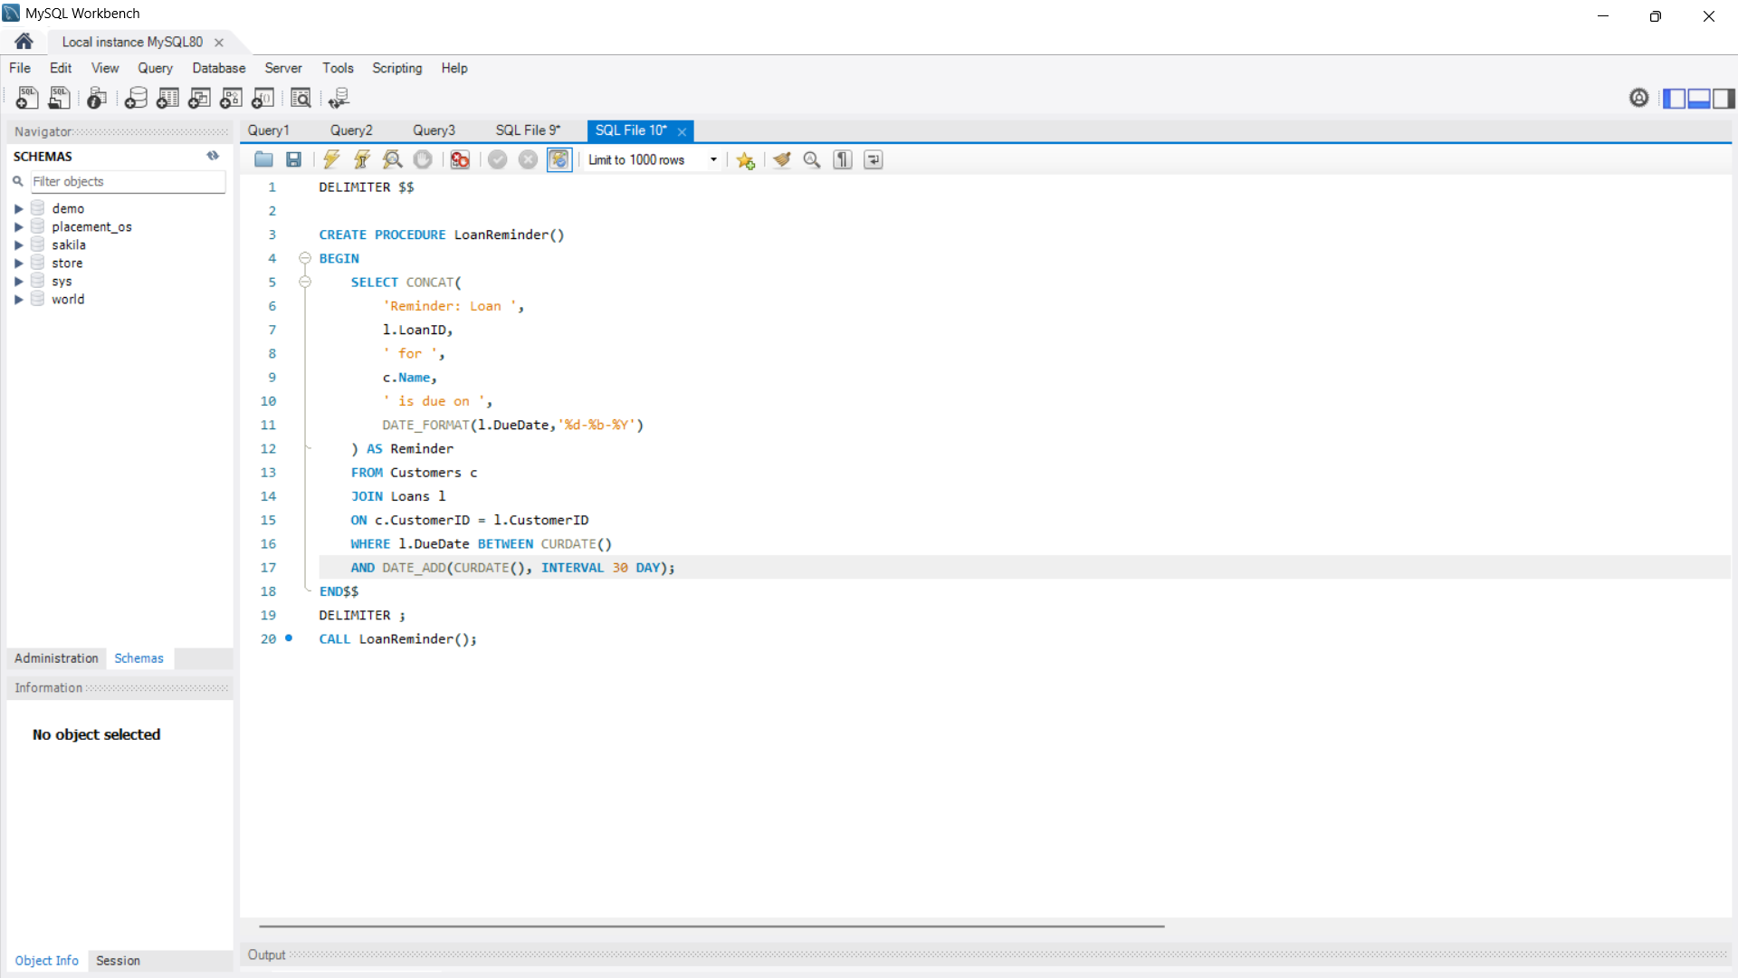
Output:
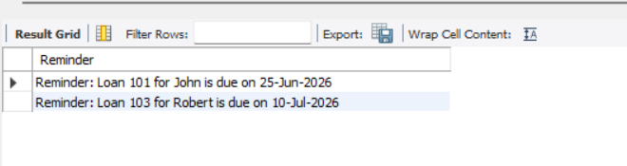
Explanation:
Displays reminder messages for all customers whose loan due date falls within the next 30 days.

